Joshua Baker- Online Diary

15/12/2020

Today I was joined by Akash Sroay and Sienna Jenkins.

The premise of the game was a board game that is heavily inspired by snakes and ladders but has other mechanics like chance cards implemented. The theme of the game is fall guys and we used that theme to incorporate elements from the game into the board such as falling off the board.

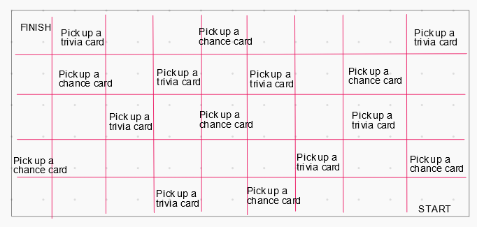Players should expect to roll dice to be able to move further on the board. There is only one dice to roll. Players should also expect: a snakes and ladders style of board game where they are to move from left to right on the board, slowly moving their way up. Trivia questions move the player forward if answered correctly. The number of spaces forward depends on the difficulty of the question. Chance cards on certain squares on the board. These cards move the player backwards on the board.

This is the board that the team created. The team used an online whiteboard to create the board.

There are certain squares that the player can land on that will affect their game. Those being chance card squares and trivia card squares.

The goal of every player is to reach the finish square.

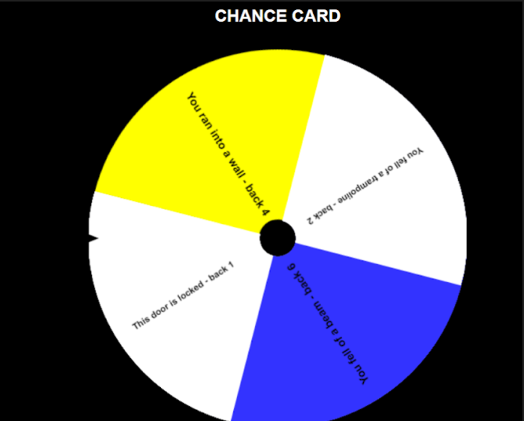Figure 1: The design of the board

Here is the list of trivia questions that will be used within the game. The list is randomly chosen.

**Trivia questions:**

* How many players are allowed into one lobby for Fall Guys?
* What do you get when winning a game of Fall Guys?
* What company developed Fall Guys?

**Play-testing:**

Originally - the game was designed to have the players move back every chance card and move back if the trivia was wrong. During play testing, it was found that this would cause the game to be long as players were always moving backwards. Therefore, the game was improved by the trivia changing to moving the player forwards if they answered the question correctly. The number of cards moved forward depends on the difficulty of the question.

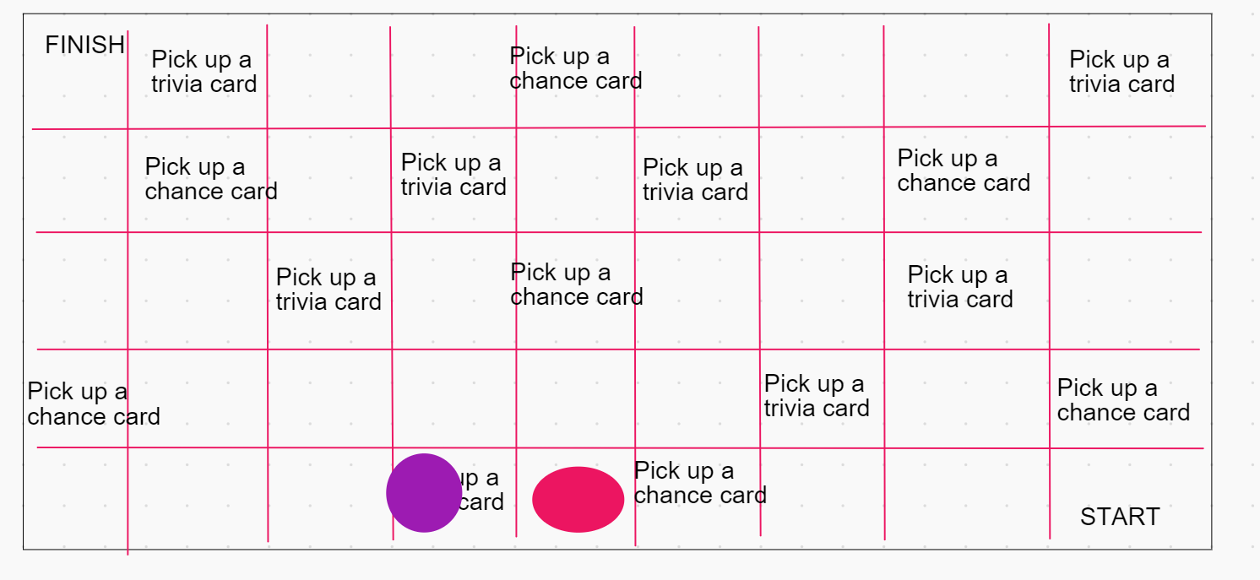External Play testers - Rowan Noble.

Figure 2: The game board being play tested

My experience working in this team solving problems felt healthy, we all contributed equally and we all suggested ideas that the team agreed upon unanimously. I think I did well in presenting and pitching the idea for our theme and also, I played a big role in most of the development of the game, such as using snakes and ladders as inspiration and building an function game around a already well established idea of a game/game board.